To parents and guardians:
About Skolelyst® fra TINE

School milk? Fruit juice? Chocolate milk?
Skolelyst® is the school milk program from TINE. Create the subscription and
pay directly on skolelyst.no. We deliver the products to the school, and the school
make sure your child gets the products in your subscription.

No artificial sweeteners
All Skolelyst product are free from artificial sweeteners, and the vast majority contain no added sugar. The beverages have a natural sugar content derived from the raw ingredients.

Product selection at your school
Each school determine their own selection of products based on the range Skolelyst offers. Lettmelk 1 % fat and Lettmelk 0,5 % fat is mandatory. Find your school’s selection here: skolelyst.no/aktuelt/sok-opp-din-skole

Sustainable lunch inspiration
Skolelyst want to encourage everyone to minimize food waste. Check out our lunch recipes that includes foods we typically let go to waste too soon: skolelyst.no/aktuelt/fra-matsvinn-til-matpakker.

Questions?
Check out our Q&A: skolelyst.no/sporsmal or contakt us on 23 288 334 or email
skolelyst@tine.no.

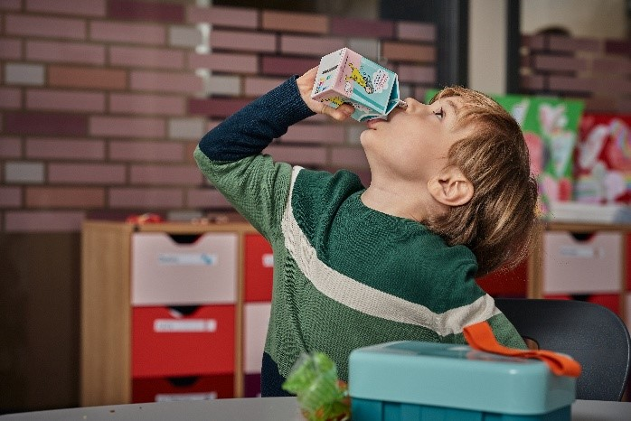 | Create an account and order now: skolelyst.no | 